|  |  |
| --- | --- |
| **General data** | **Description** |
| **Proposal ID** | 20230619 |
| **Customer** | STABILUS |

|  |  |  |  |
| --- | --- | --- | --- |
| **Approval Tracking** | **Date** | **Signature** | **Personal Data (e-mail / Telephone)** |
|  |  |  |  |
|  |  |  |  |

|  |  |  |  |  |  |  |
| --- | --- | --- | --- | --- | --- | --- |
| **See** | **Description Event / Change** | **Change Date** | **Requested by** | **Approved by** | **Modified by** | **Hours / Days** |
| 01 | Document Creation | 06/19/2023 |  |  | pavel garcia |  |
|  |  |  |  |  |  |  |

table of Contents

1  Introduction  3

2  Objective  3

3  Previous Considerations / Premises  4

3.1  General  4

3.2  Proposal  4

4  SAP DRC eDocument / AIF – Mexico  4

5  Payment Add-on – ePayment 2.0  6

5.1  SAT  6 Catalogs

5.2  Send Electronic Invoice Data  6

5.3  Stamped Invoice Reception  7

5.4  Supported Scenarios  8

6  PAC Integration  9

7  Work Plan  9

8  Support and Warranty Policy  10

9  Economic Proposal  11

9.1  Investment  11

9.2  Support and Warranty Policy  11

9.3  Commercial Conditions  11

# Introduction

The electronic invoice is the digital representation of an invoice, it is called Digital Fiscal Receipt via Internet (CFDI), it is attached to the standards defined by the SAT in Annex 20 of the Fiscal Miscellaneous Resolution and can be generated, transmitted and safeguarded using electronic media.

Each electronic invoice issued has a digital seal (Advanced Electronic Signature) that corroborates its origin and validates it before the SAT (Tax Administration System), an original string that works as a summary of the invoice content and a page that indicates the transaction number, which is sent to the so-called PAC (Authorized Certification Provider).

SAP Document and Reporting Compliance (SAP [DRC](https://help.sap.com/docs/SAP_S4HANA_CLOUD/71af4585db6d4904b1724730f3776c9b/39b43ed2a9c243d392e0d7cf049e5ab9.html?locale=es-ES) ) is a solution that offers electronic integration with tax entities, and mandatory legal reports for all countries.

For Mexico SAP DRC supports the following legal requirements:

* Issuance of Electronic Invoice CFDI 4.0 ( eInvoice 4.0)
* Issuance Supplement Payment 2.0 ( ePayment 2.0)
* Legal Reports: Electronic Accounting, VAT Declaration, DIOT Report, Withholding Declaration

Tax regulations for Mexico are complex and SAP DRC does not cover all scenarios within the company. The WISE solution is geared towards complementing the standard SAP solution with a variety of special scenarios from different industry sectors. WISE offers the following additional functionalities to the standard SAP solution:

* Customer Specific Scenarios
* Tax Legends
* Foreign trade
* Bill of Lading
* Addenda Generation Module

To support electronic integration, SAP DRC offers its eDocument and AIF ( Application Interface Framework).

# Aim

* Activate the functionality of SAP eDocument / AIF for Mexico
* Generate the XML with the following information:
  + Payment Plugin Version 2.0
  + Customer Specific Scenarios
* Electronic invoice cancellation process
* Invoice printing and PDF generation
* Store XML/PDF Electronic Invoice in Document Manager
* Electronic invoice integration control monitor (EDOC_COCKPIT)
* Integration with the PAC through a Middleware (SAP PI/PO, SAP Cloud Integration , SOAMANAGER-Web Services )

# Previous Considerations / Premises

## generals

* It is necessary to have remote access to the Client's servers
* It is the CUSTOMER's responsibility to enable SAP communication with the Middleware/PAC
* After 10 days have elapsed without a response from the client after having delivered the works for the comprehensive testing phase, they will be considered approved and the Wise team will be deallocated and to proceed with the reactivation of the project it will be necessary to additionally cover an economic percentage on the original value of the requirement.

## Proposal

* Have an Authorized PAC Provider.
* The response times of the PAC provider are not the responsibility of the solution to be implemented.
* The client must have configured the standard processes of:
  + Customer advances
  + Taxes and Customer Withholdings
* The CLIENT is responsible for having SAP AIF updated with version 4 for Mexico (GLO-EDO-MX-40 package) that the " Service " has available. Consumer ” CFDIeDocumentsV4 (Notes Application).
* The CLIENT is responsible for preparing the data for the unitary and integral tests in the development and quality instance.

# SAP DRC eDocument / AIF – Mexico

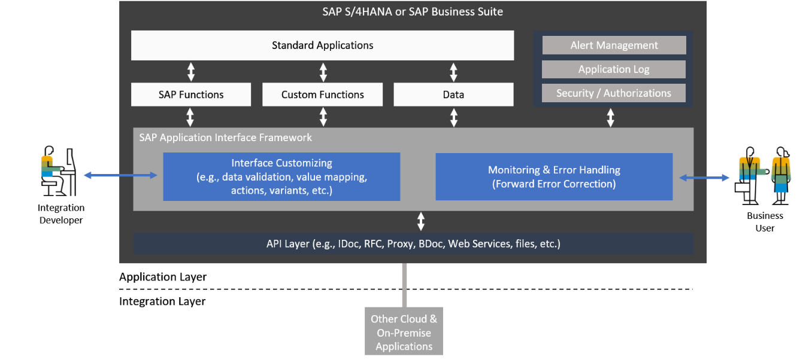

[eDocument](https://snitechnology.net/sap-edocuments-framework-2/) architecture (Similar to IDOC) that allows extracting information from SAP transactions and sending them to a Middleware through Application Interface Framework (IAF).

SAP [Application Interface Framework](https://blogs.sap.com/2019/06/06/sap-application-interface-framework-all-you-need-to-know-about-sap-aif/) (AIF) is the module that is installed in SAP ERP or S4 Hana to validate, generate an XML to send it to a middleware (SAP Cloud Integration , SAP PI/PO, Web Services -SOA) for its integration with a tax entity.

The supported Middleware are:

* SAP PI/PO
* SAP Cloud Integration
* SOAMANAGER (Web Services )

SAP has released version 4 of SAP AIF for Mexico, which covers all the requirements for CFDI 4.0 and the Payment Complement 2.0



For the adaptations of each client or complex scenarios, SAP has released the following extensions:

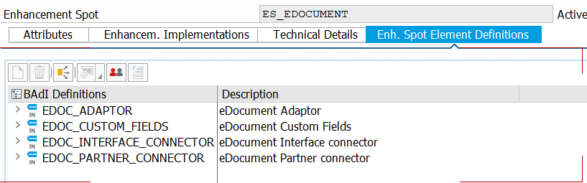

**eDocument Monitor – Cockpit**

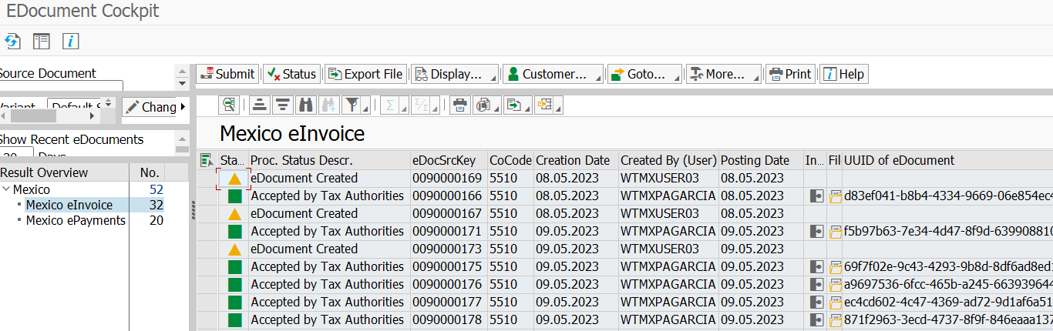

A monitor is offered to centralize electronic invoices with the following functionalities:

* Centralize by Country, by type eInvoice / ePayment
* Filters: Company, SD/FI Source Type, Dates, SD/FI Source Documents
* Send/Forward Ringback
* Log Errors
* Cancellation eInvoice / ePayment
* View XML and Print PDF

# Payment Plugin – ePayment 2.0

## SAT catalogs

SAP AIF offers a /AIF/VMAP transaction to centralize the following SAT catalogues:



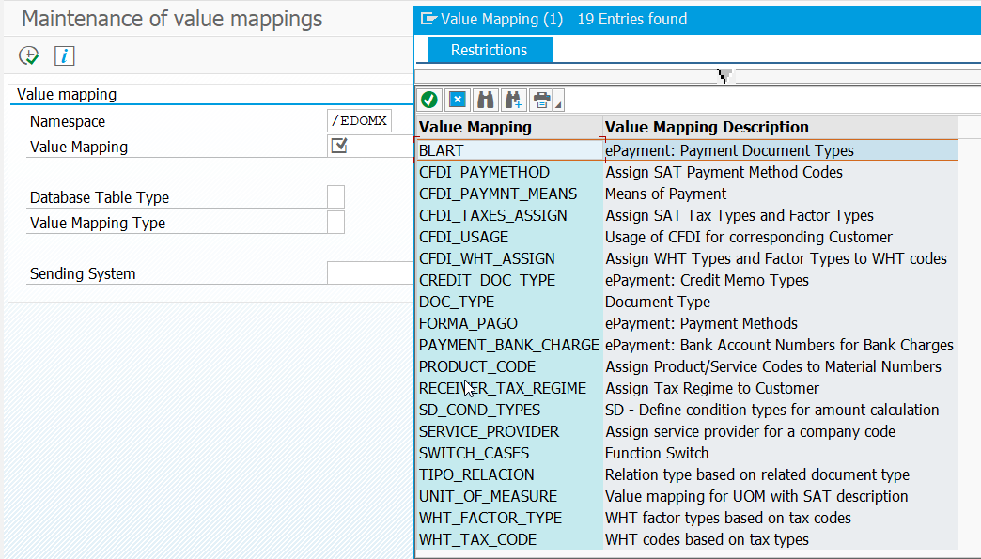

If customers need to extract the data differently, additional development is required.

## Send Electronic Invoice Data

All data to be sent to the Middleware is generated

* XML Electronic Invoice
* XML Payment Plugin
* XML Special Scenarios

## Stamped Invoice Reception

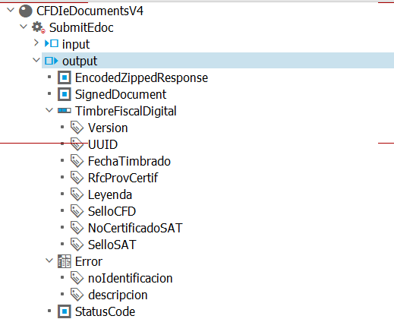

* The PAC returns the ringing result to SAP AIF through the Middleware
* In SAP AIF receives the XML and the following processes are executed:
  + Update the control status of the invoice monitor ( Cockpit )
  + Update ringing data
  + Update Error Log

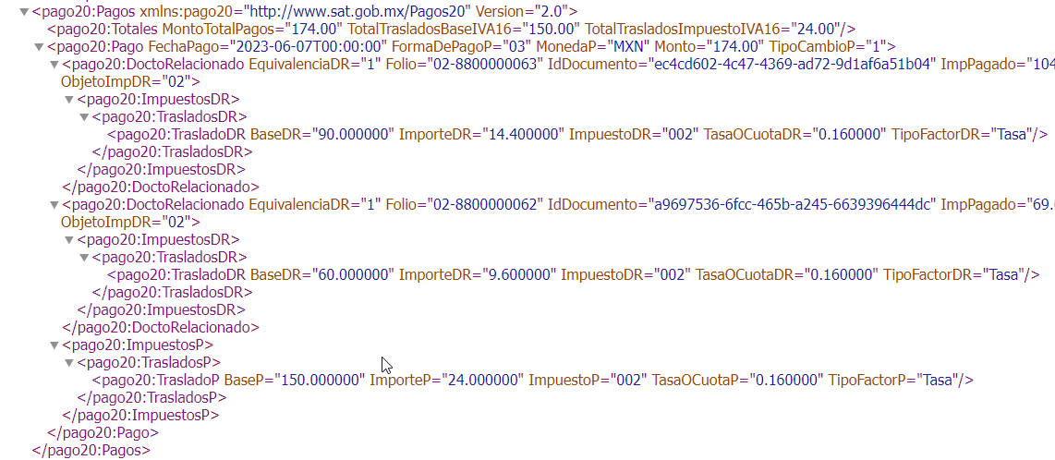

## Supported Scenarios



# PAC integration



# Workplan



# Support and Warranty Policy

Considering that WISE is continually updating the solution and that, in addition, part of it has embedded validations from the SAT, who can release any modification to the tax reform at any time, the policy must be contracted from the start of the project and additionally , must be renewed for the first year. From the second year it is optional. During the term of the policy includes at no cost:

1. **WARRANTY**The solution of any errors that appear in the scenarios that were tested and installed during the implementation project. This point is mainly based on the TO BE document approved by the client.

1. **MEDIUM** Grants the security of use of the solution during the validity of the policy, under any circumstance.

1. **SAT UPDATE** It allows the solution to be kept up to date with the tax provisions of the SAT every time that updates or adjustments are made by the agency, in order to maintain 100% compliance with government obligations in Tax matters.

1. **WISE UPDATE** Update of the solution, through the installation of the improvements developed by WISE. These can be carried out for the purposes of:

* improve performance
* Migration to another Vanguard Technology
* increased functionality

1. **HANNA MIGRATION** FREE adaptation of our solution to SAP S/4 HANA, as long as you have a policy with a minimum validity of 6 months

1. **PREFERENTIAL RATES** If the change or update requirement of the solution is due to something ad-hoc of the client, this can be done without cost in case it adds value to our solution or be quoted at preferential rates.

1. **PROJECT CONTINUITY** If, for reasons specific to the project, it extends over time, but does not stop, or the work has not started, by decision of the CLIENT, WISE will continue or start work while the policy is in force.
2. **SAT RELEASES** All our clients are kept informed about tax reforms regarding the solutions we provide, so that they can take the necessary actions to keep up to date.

If a program is modified by the client, the guarantee of the policy will be invalidated. In the event that the client, due to urgent needs, requires making a change, this must be coordinated with WISE to keep the solution updated and determine that this change does not have an excessive impact on the base configuration of the solution.

It is also worth mentioning the following aspects that our policies do not include:

* Management of the services agreed with the PAC by the client.
* Update of master data, registration, cancellation or modification of users.
* Basis attentions or PI.

# Economic proposal

## Investment

|  |  |
| --- | --- |
| **Topics** | **USD amount** |
| Payment Addon 2.0 |  |
| Special Scenarios Client |  |
| **FULL SCOPE** |  |

## Support and Warranty Policy

|  |  |
| --- | --- |
| **policies** | **USD amount** |
|  |  |
| **FULL SCOPE** |  |

*Required for the first year, and from the second year it is optional

## Commercial terms

* The indicated investment does not include VAT.
* The investment does not include travel expenses, which if given would be according to the policies established by the Client.
* Quotation valid for 30 days from the date of delivery of the proposal.
* Once the requirement is accepted, either with confirmation received by mail or purchase order, this will be taken as final and cannot be canceled, subject to the following considerations.
  1. If the client withdraws before the project has started, it must cover WISE the 30% of the agreed payment for acceptance of the proposal.
  2. If the client cancels after the project has started, then it must cover the entire amount agreed in the proposal, that is, 100% of the quoted amount.
* The billing form for payment within 30 days is for the 100% policy at the beginning of the project and for the implementation of the solution is as follows:
  + 30% upon acceptance of the proposal
  + 20% upon delivery of the ToBe document
  + 20% to the release of the solution for the client to carry out their comprehensive tests
  + 20% upon completion of comprehensive tests
  + 10% upon delivery of documentation and final acceptance